**Python for Applied Physics**

**Lab Activity – 1**

1. Prepare the code of the following two outputs on Jupyter notebook using markdown

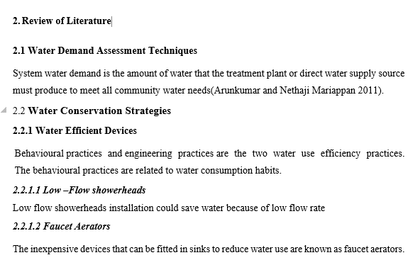 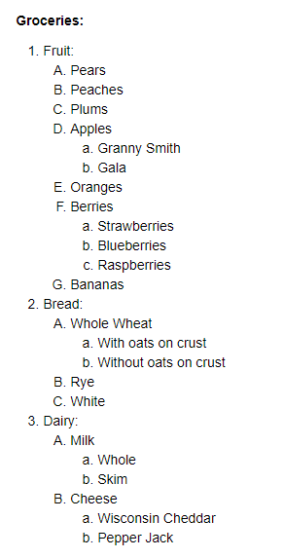

1. Make code for the following a table on markdown cell.\

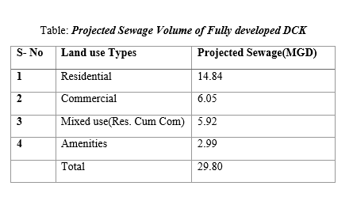

1. Make code for (i) Add our own photograph from your system(PC or laptop) (ii) Add any image from website.
2. Make code for any link of your favorite online course website ( e.g Coursera or Edx or Udemy ).